Marine Robotics / Computer Vision / github.com/Bakel-Bakel/bluerov-computer-vision
BlueROV Computer Vision System
PROJECT DESCRIPTION
This project gives the BlueROV underwater vehicle the ability to see and react to what its camera is looking at. A live video stream is pulled from the ROV, processed frame by frame in Python with OpenCV, and used to detect coloured targets in the water. The system handles the messy parts of underwater imaging up front: an HSV calibration step lets the operator dial in the colour signature of the target on the day, since lighting underwater never behaves the way it does on dry land. Once the target is locked in, the detector tracks its position and bounding area in every frame, and a simple area to distance model converts that pixel area into an estimate of how far the target is from the ROV. The control side closes the loop. Detection output feeds into the ROV's MAVLink control channel so the vehicle can adjust its heading and drive forward toward the target at a tuned thrust setting, turning the camera into more than just a passive sensor and giving the ROV a real, working visual servoing capability.
TECHNOLOGIES & SKILLS
Python | OpenCV | MAVLink | HSV Colour Space
Image Processing | Object Detection | Visual Servoing | Underwater Imaging
Camera Streaming | Distance Estimation | ROV Control | Real Time Vision
TECHNICAL HIGHLIGHTS
- Live video stream pulled from the BlueROV and processed frame by frame in Python with OpenCV.
- Interactive HSV calibration tool that lets the operator tune the colour mask for the actual lighting on the day.
- Colour based target detector that finds the object in the frame and tracks its bounding contour over time.
- Area to distance estimator that converts pixel area of the detected target into an approximate range from the camera.
- Closed loop integration with the ROV control system, sending forward thrust commands at a calibrated PWM value once the target is locked.
- Modular layout with separate folders for HSV calibration, area to distance, and control system, so each block can be swapped or retuned on its own.
PICTURES
BLOCK DIAGRAM
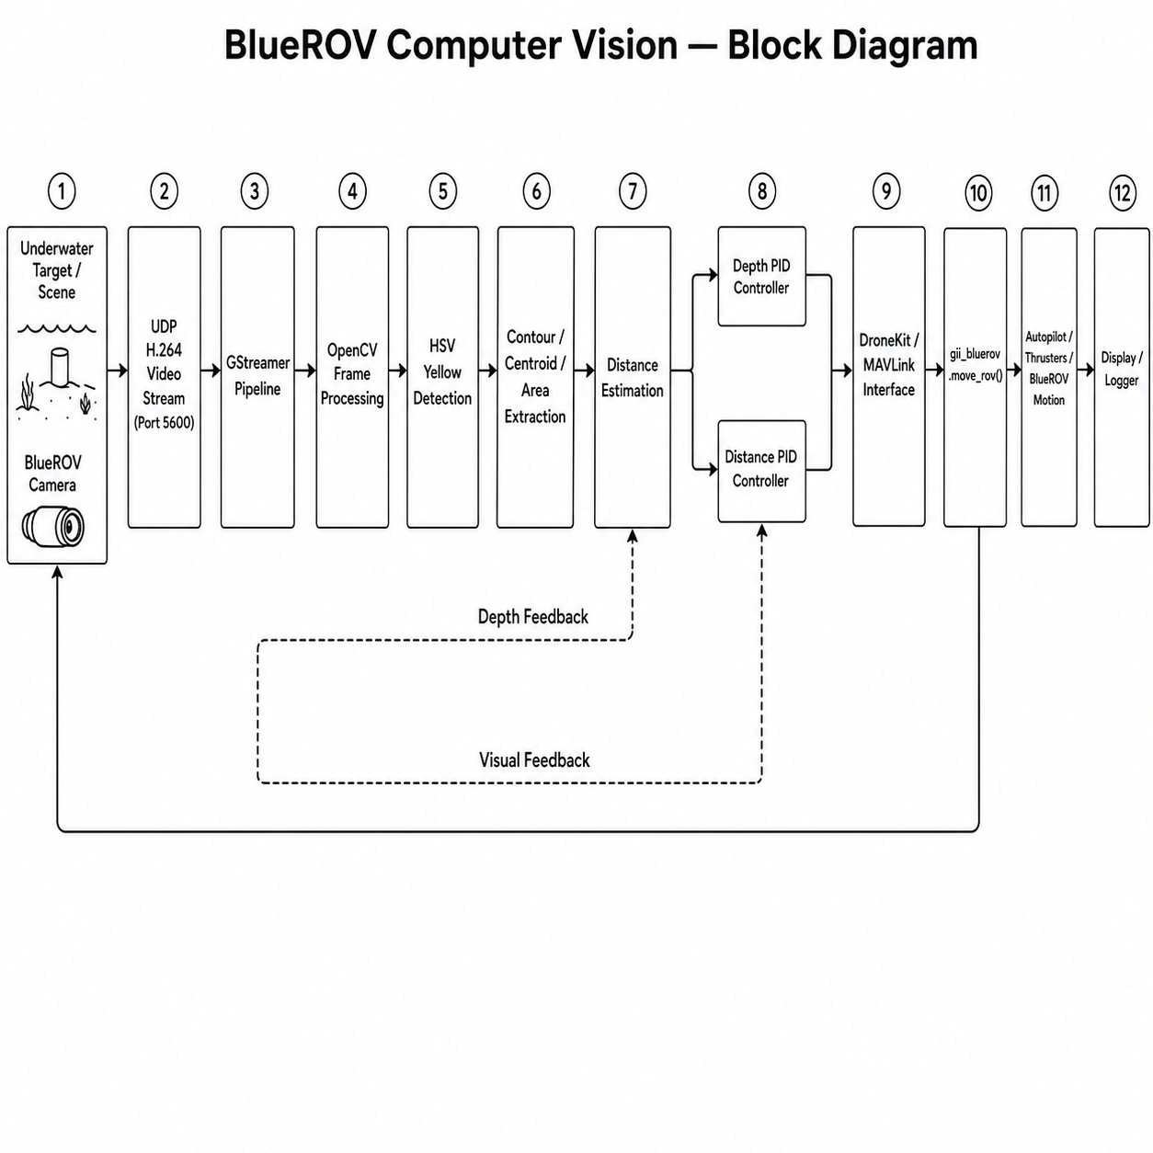

FLOWCHART
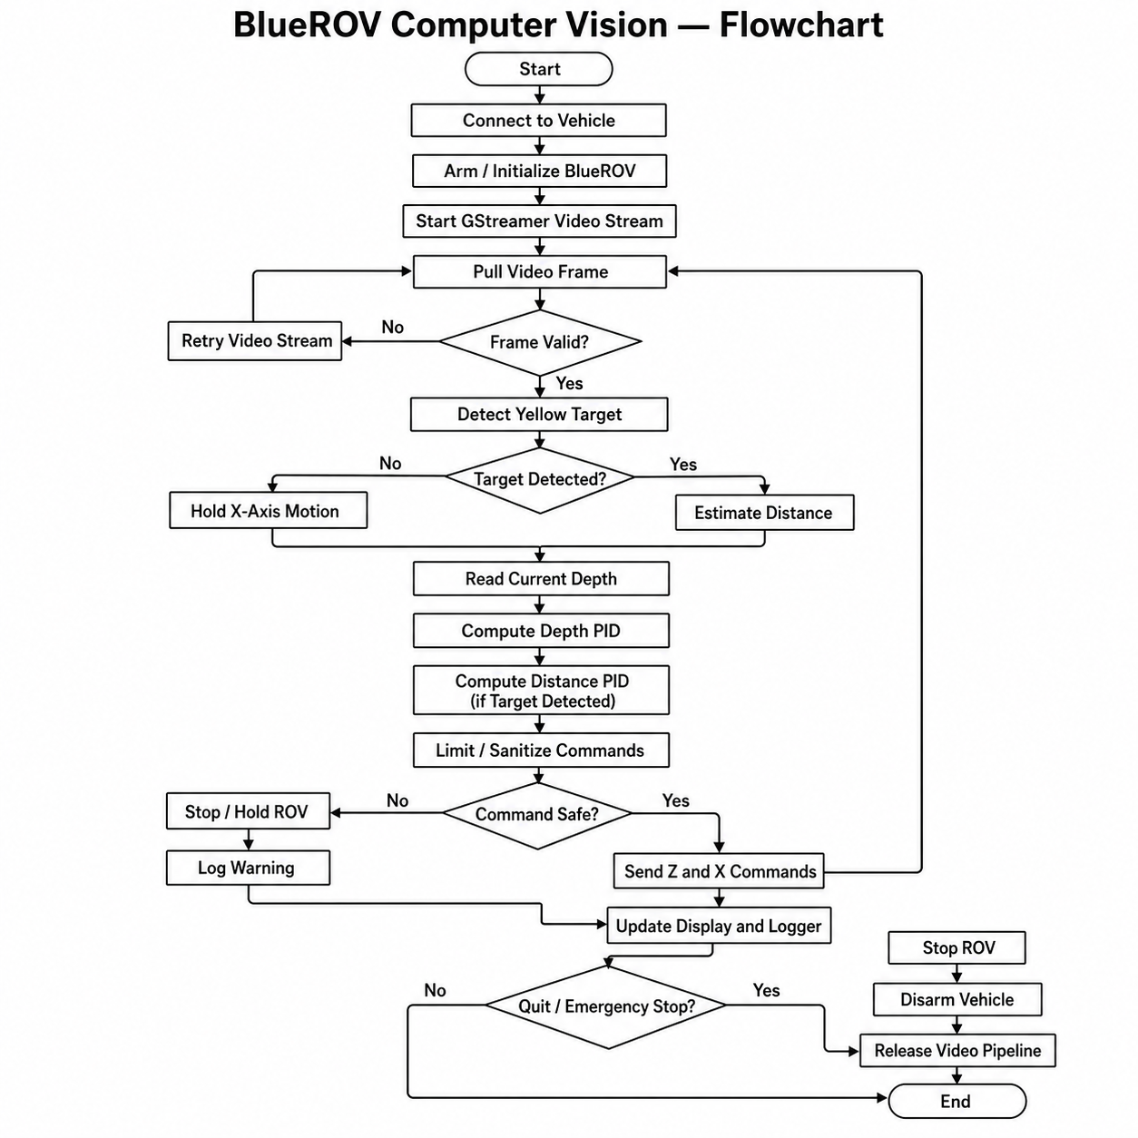
SEQUENCE DIAGRAM
